CERTIFICATE



# R. D. AND S.H. NATIONAL COLLEGE AND

**S. W. A. SCIENCE COLLEGE**

BANDRA, MUMBAI - 400 050.

## Department of BSC-IT

This is to certify that Mr/Miss Seat No :- of Satisfactory completed :- Practicals, in the subject of

During the academic year 202_- 202_

|  |  |  |
| --- | --- | --- |
| Term | No of Practicals | Signature |
|  |  |  |

Teacher Incharge Incharge

Department of BSC-IT

Signature of Examiner

**Index**

|  |  |  |  |
| --- | --- | --- | --- |
| **Sr.No.** | **Title** | **Date** | **Remark** |
| **1** | To Perform Arithmetic Operation Using Servlet | 30/06/23 |  |
| **2** | To validate a user by Name and password. | 30/06/23 |  |
| **3** | Display implicit object by JSP. | 07/07/23 |  |
| **4** | To find number times user visited the page. | 07/07/23 |  |
| **5** | To update SQL table by JSP page. | 14/07/23 |  |
| **6** | Currency converter Program | 14/07/23 |  |
| **7** | Use of Request Dispatcher to welcome user | 21/07/23 |  |
| **8** | Working with JSTL. | 21/07/23 |  |
| **9** | To view data from database after submitting.. | 28/07/23 |  |
| **10** | Register user in database(Room booking) | 28/07/23 |  |
| **11** | Validating user by JSP. | 04/08/23 |  |
| **12** | Create a registration and login JSP application to register and authenticate the user | 04/08/23 |  |
| **13** | Create a Servlet Application To Uploading File. | 11/08/23 |  |
| **14** | Create a Servlet Application to download File | 11/08/23 |  |
| **15** | To Create Quiz using Servlet | 25/08/23 |  |
| **16** | Expression language by using JSP | 25/08/23 |  |
| **17** | Use JDBC for data insertion for valid user | 08/09/23 |  |

**Practical 1**

# AIM: To Perform Arithmetic Operation using Servlet.

## HTML Code: index.html

<html>

<head>

<title>Calculator</title>

</head>

<body>

<form action="NewServlet">

Enter First Number <input type="text" name="txtN1"><br> Enter Second Number <input type="text" name="txtN2"><br> Select an Operation<br>

<input type="radio" name="opr" value="+">ADDITION<br>

<input type="radio" name="opr" value="-">SUBTRACTION<br>

<input type="radio" name="opr" value="*">MULTIPLY<br>

<input type="radio" name="opr" value="/">DIVIDE <br>

<input type="reset"><br>

<input type="submit" value="Calculate">

</form>

</body>

</html>

## Java Code: NewServlet.java

package com.test;

import java.io.IOException; import java.io.PrintWriter;

import javax.servlet.ServletException; import javax.servlet.http.HttpServlet;

import javax.servlet.http.HttpServletRequest; import javax.servlet.http.HttpServletResponse; public class NewServlet extends HttpServlet {

public void doGet(HttpServletRequest request, HttpServletResponse response) throws ServletException, IOException

{ response.setContentType("text/html;charset=UTF-8"); PrintWriter out = response.getWriter();

out.println("<html><head><title>Servlet CalculatorServlet</title></head><body>");

double n1 = Double.parseDouble(request.getParameter("txtN1")); double n2 = Double.parseDouble(request.getParameter("txtN2")); double result =0;

String opr=request.getParameter("opr"); if(opr.equals("+"))

result=n1+n2; if(opr.equals("-")) result=n1-n2; if(opr.equals("*")) result=n1*n2; if(opr.equals("/")) result=n1/n2;

out.println("<h1> Result = "+result); out.println("</body></html>");

}

}

**OUTPUT:**

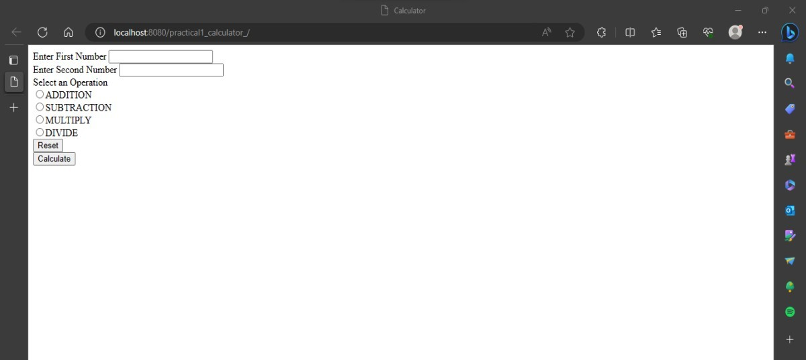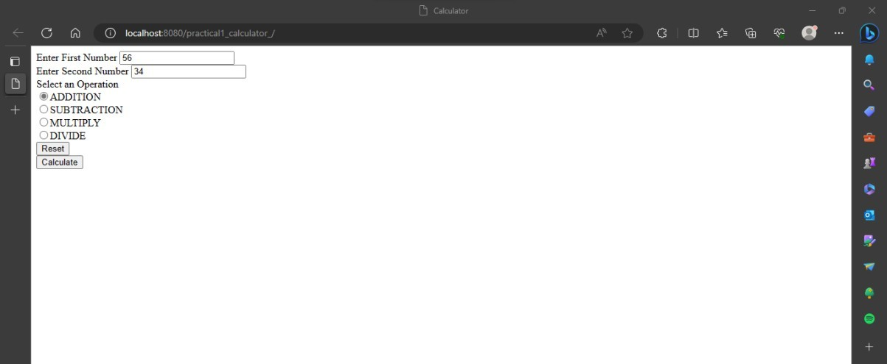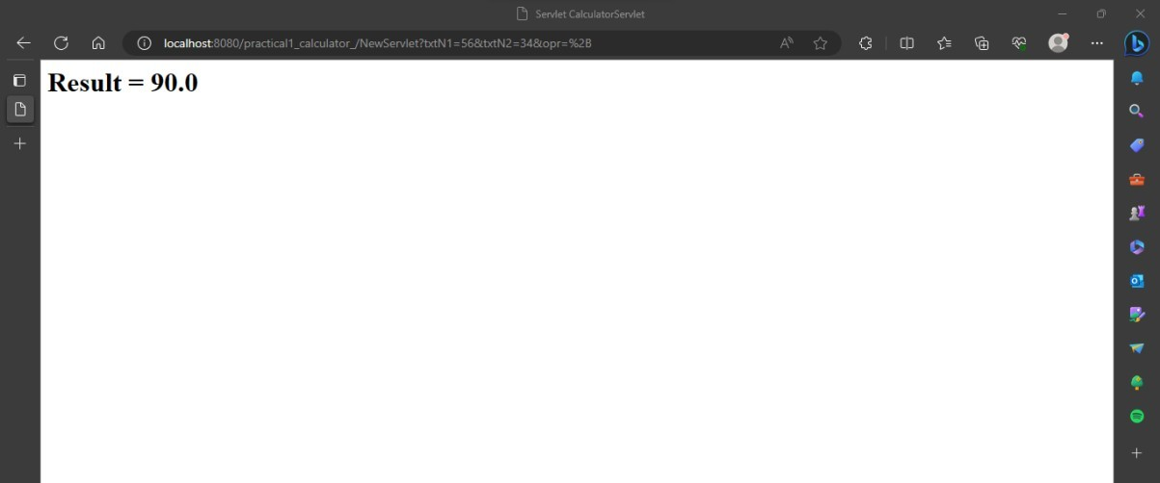

## Practical 2

**Aim: To validate a user by Name and password. HTML Code: index.html**

<html>

<head>

<title>Login Form</title>

</head>

<form action="NewServlet">

Enter User ID<input type="text" name="txtId"><br>

Enter Password<input type="password" name="txtPass"><br>

<input type="reset">

<input type="submit" value=" Click to Login ">

</form>

</html>

**Servlet Code: NewSerevlet.java**

package mypack; import java.io.*;

import javax.servlet.ServletException; import javax.servlet.http.*;

public class NewServlet extends HttpServlet {

public void doGet(HttpServletRequest request, HttpServletResponse response) throws ServletException, IOException

{ response.setContentType("text/html;charset=UTF-8"); PrintWriter out = response.getWriter();

out.println("<html><head><title>Servlet LoginServlet</title></head>");

String uname = request.getParameter("txtId"); String upass = request.getParameter("txtPass"); if(uname.equals("admin") &&upass.equals("12345")){out.println("<body bgcolor=blue >"); out.println("<h1> Welcome !!! "+uname+"</h1>");

}

else{

out.println("<body bgcolor=red >");out.println("<h1> Login Fail !!! </h1>");

}

out.println("</body></html>");}}

**Output:**

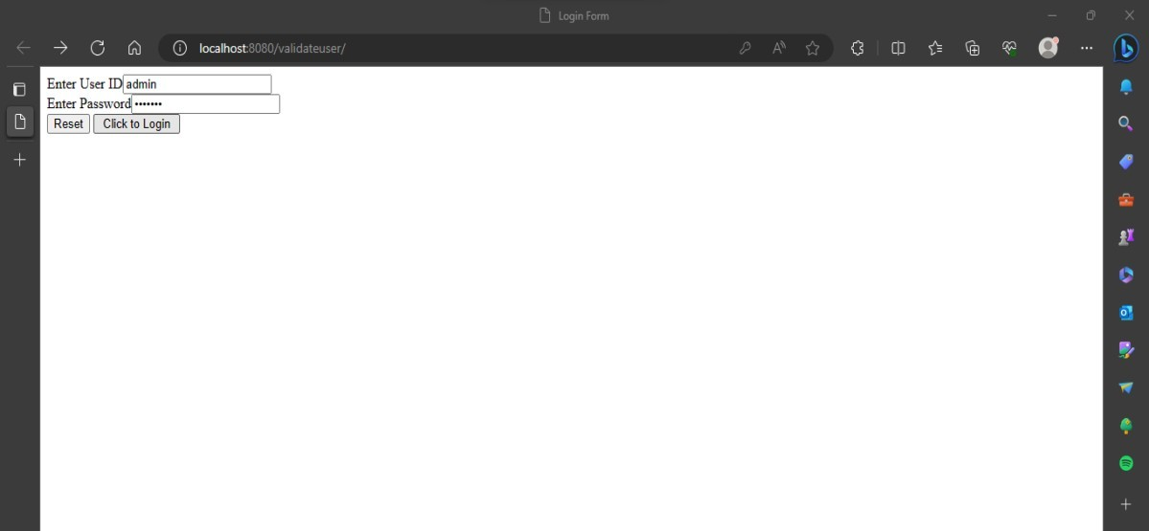

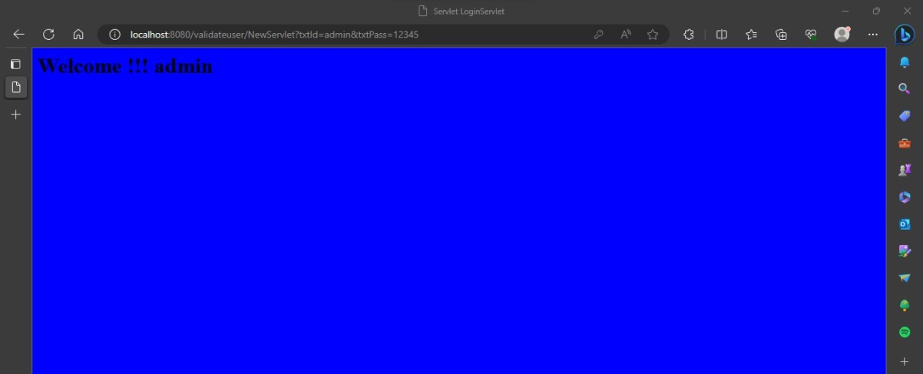

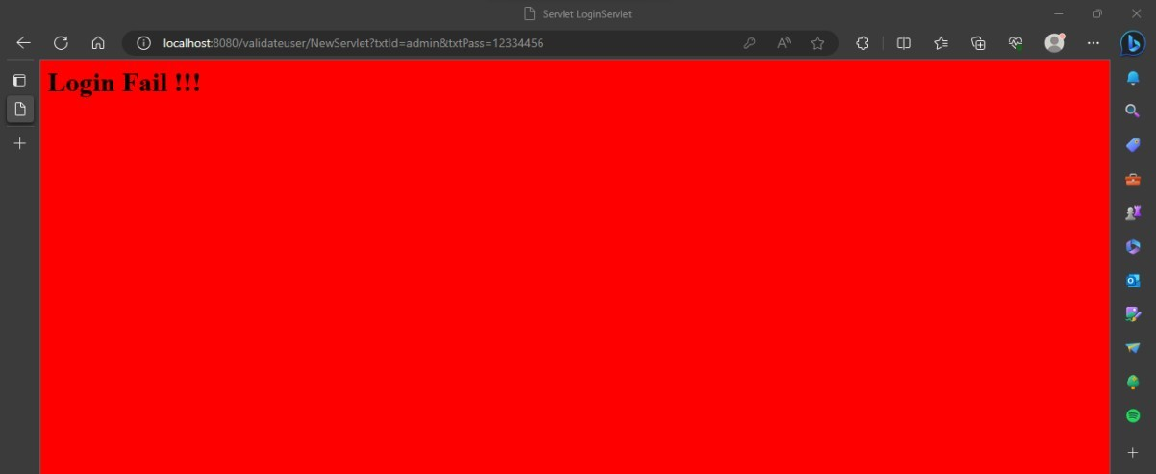

## Practical 3 AIM: Display implicit object by JSP.

**JSP Code:**

<%@page contentType="text/html" pageEncoding="UTF-8"%>

<!DOCTYPE html>

<html>

<head>

<meta http-equiv="Content-Type" content="text/html; charset=UTF-8">

<title>JSP Page</title>

</head>

<body>

<h1>Use of Intrinsic object in JSP</h1>

<h1>Request Object</h1>

Query String <%=request.getQueryString() %><br> Context Path <%=request.getContextPath() %><br> Remote Host <%=request.getRemoteHost() %><br>

<h1>Response Object</h1>

Character Encoding Type <%=request.getCharacterEncoding() %><br> Content Type <%=request.getContentType() %><br>

Locale <%=request.getLocale() %><br>

<h1>Session Object </h1>

ID <%=session.getId() %><br>

Creation Time <%= new java.util.Date(session.getCreationTime()) %><br> Last Access Time <%= new java.util.Date(session.getLastAccessedTime())

%>

</body>

</html>

## Output:

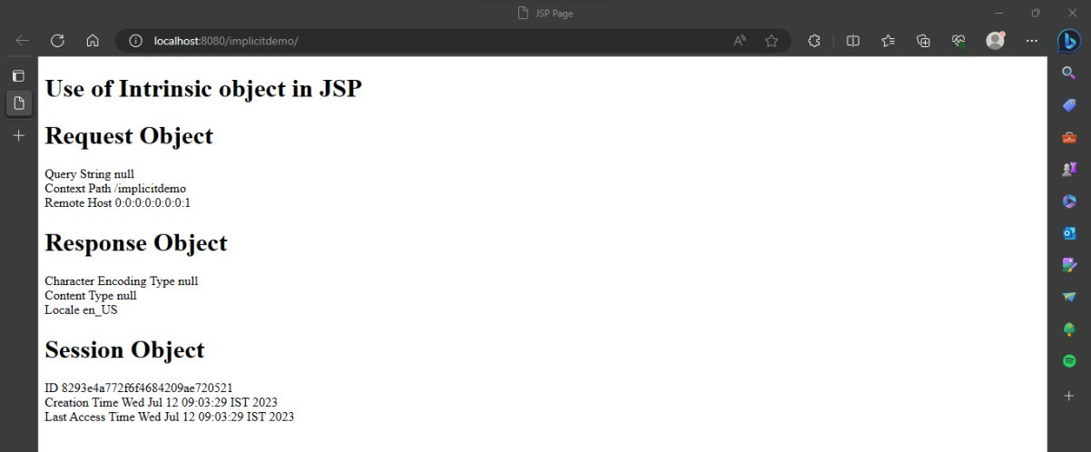

**Practical 4**

## Aim: To find number times user visited the page. Html Code: index.html

<html>

<head>

<title>Login Form</title><meta charset="UTF-8">

<meta name="viewport" content="width=device-width, initial-scale=1.0">

</head>

<body>

<form action="NewServlet">

<center><h1>Login Cookie For Demo</h1></center> Enter User ID <input type="text" name="txtId"><br><br>

Enter Password<input type="password" name="txtPass"><br><br><input type="reset">

<input type="submit" value=" click to Login ">

</form>

</body>

</html>

**Java Code:NewServlet.java**

import java.io.*; import javax.servlet.*;

import javax.servlet.http.*;

public class NewServlet extends HttpServlet

{

static int i=1;

public void doGet (HttpServletRequest request, HttpServletResponse response) throws IOException, ServletException

{

response.setContentType ("text/html"); PrintWriter out = response.getWriter(); String k=String.valueOf(i);

Cookie c = new Cookie ("visit", k); response.addCookie(c) ;

int j=Integer.parseInt (c.getValue ()) ; if (j==1)

out.println("Welcome"); else

out.println("<font color=blue> oho genious</font›<br>"); out.println("You visited "+i+" times");

i++;}}

## Output:

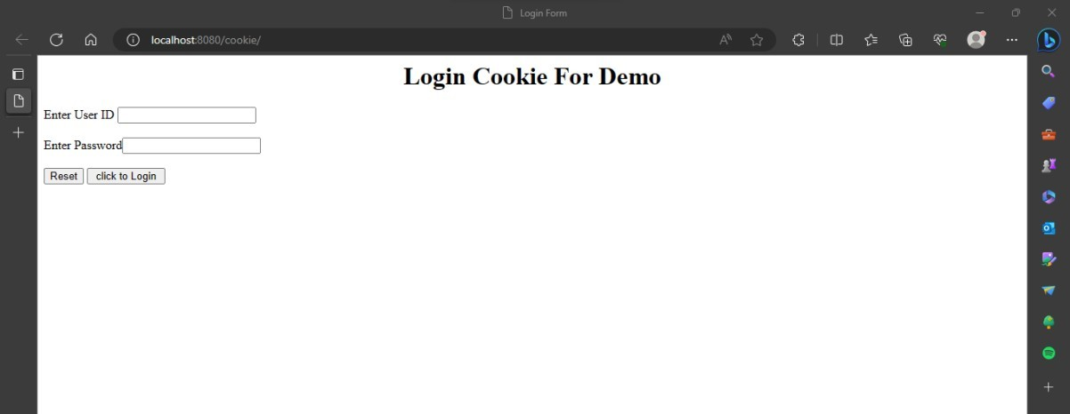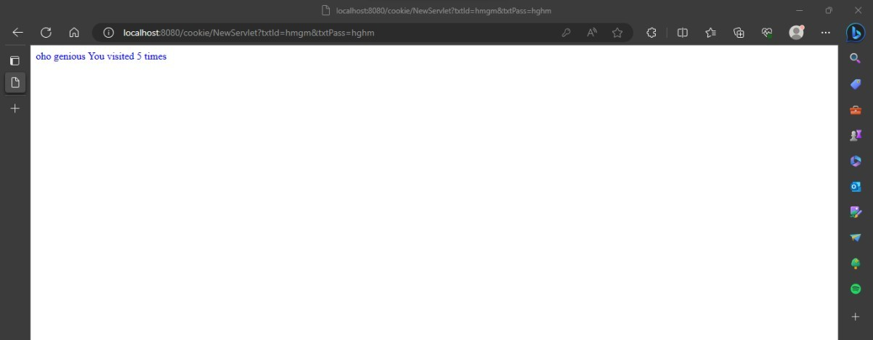

**Practical 5 Aim: To update sql table by JSPb page. HTML Code: index.html**

<html>

<body>

<form action="UpdateEmp.jsp">

Enter Employee Number<input type="text" name="txtEno"><br> Enter Name<input type="text" name="txtName"><br>

Enter age<input type="text" name="txtAge"><br> Enter Salary<input type="text" name="txtSal"><br>

<input type="reset"><input type="submit">

</form>

</body>

</html>

## JSP Code:UpdateEmp.jsp

<%@page contentType="text/html" import="java.sql.*" %>

<html><body>

<h1>Employee Record Update</h1>

<%

String eno=request.getParameter("txtEno"); String name=request.getParameter("txtName"); String age = request.getParameter("txtAge"); String sal = request.getParameter("txtSal");

try{ Class.forName("com.mysql.jdbc.Driv er");

Connection con = DriverManager.getConnection("jdbc:mysql://localhost:3306/test","root","hr");

PreparedStatementstmt = con.prepareStatement("select * from emp where empid=?"); stmt.setString(1, eno);

ResultSetrs = stmt.executeQuery(); if(rs.next()){

out.println("<h1>~~~ Employee "+name+" Exist ~~~ </h1>");

PreparedStatement pst1= con.prepareStatement("update emp set salary=? where empid=?");

PreparedStatement pst2= con.prepareStatement("update emp set age=? where empid=?"); pst1.setString(1, sal); pst1.setString(2, eno);

pst2.setString(1, age); pst2.setString(2, eno); pst1.executeUpdate(); pst2.executeUpdate();

}

else{

out.println("<h1>Employee Record not exist !!!!!</h1>");

}

}catch(Exception e){out.println(e);}

%></body></html>

## Output:

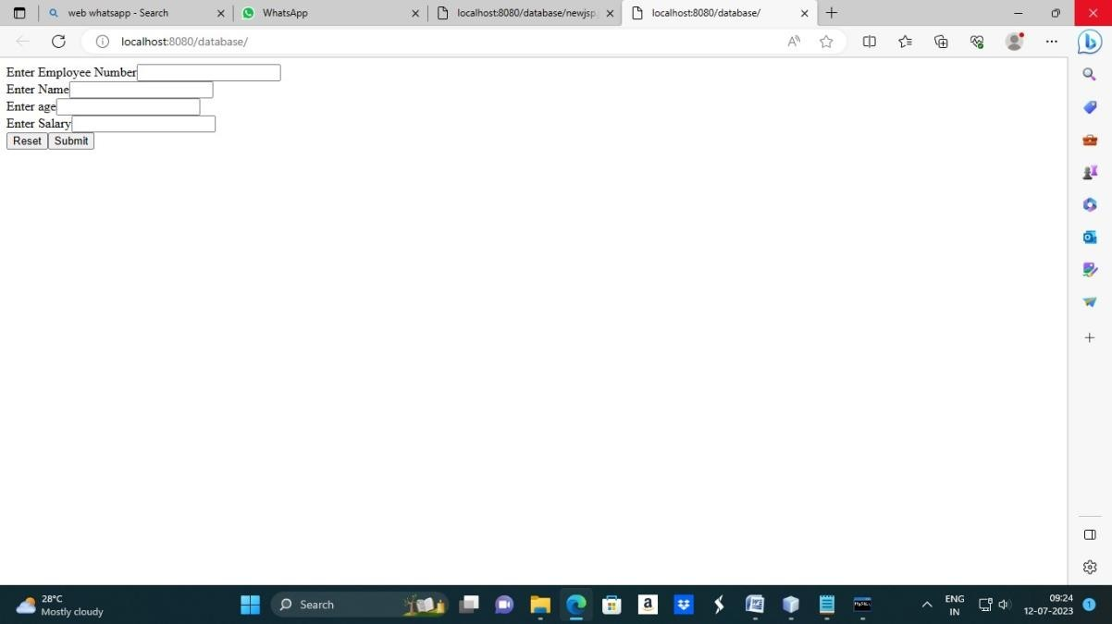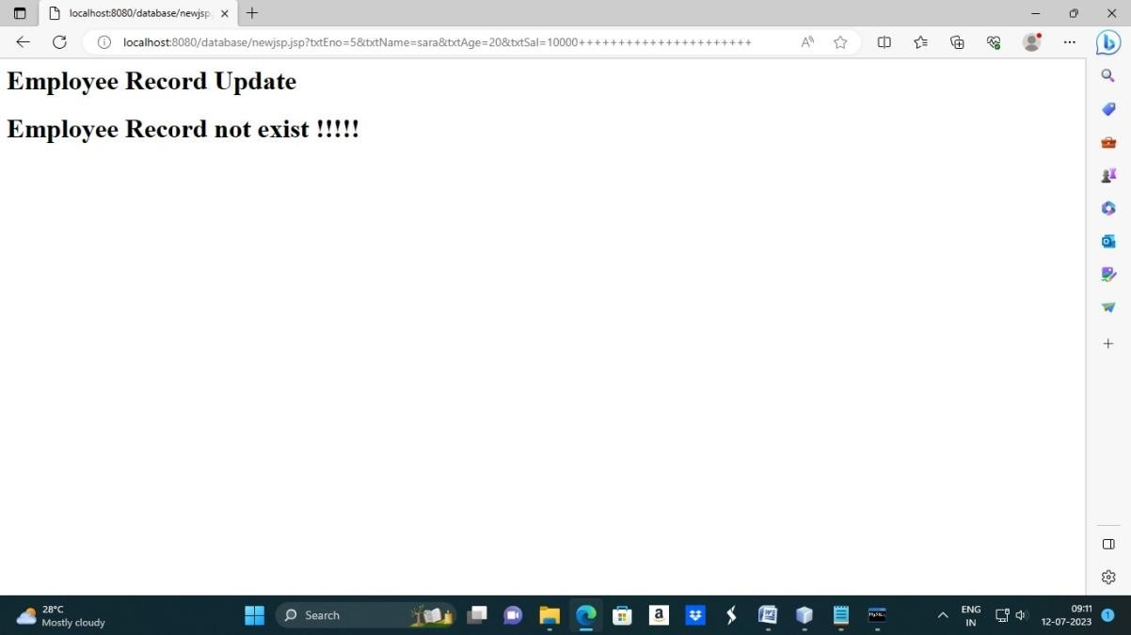

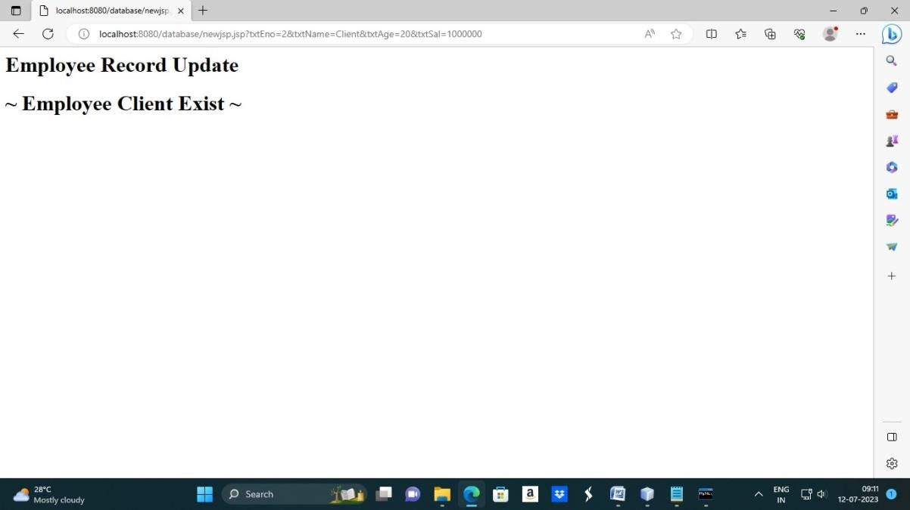

**>>create database practical;**

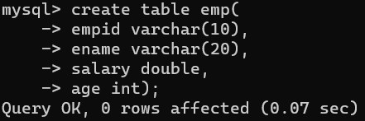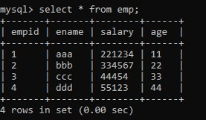

## Practical 6 Aim: Currency converter Program.

**HTML Code:index.html**

<html>

<head>

<title>Currency Converter</title>

</head>

<body>

<form action="NewServlet">

Enter Amount <input type="text" name="amt"><br> Select Conversion Type

<input type="radio" name="type" value="r2d" checked>Rupees to Dollar

<input type="radio" name="type" value="d2r">Dollar to Rupees<br>

<input type="reset"><input type="submit" value="CONVERT">

</form>

</body>

</html>

## Servlet 1 code: NewServlet.java

package mypack; import java.io.*; import javax.servlet.*;

import javax.servlet.http.*; import javax.ejb.EJB; import mybeans.ccbeans;

public class NewServlet extends HttpServlet {

@EJB ccbeans obj;

public void doGet(HttpServletRequest request, HttpServletResponse response) throws ServletException, IOException

{ response.setContentType("text/html;charset=UTF-8"); PrintWriter out = response.getWriter();

double amt = Double.parseDouble(request.getParameter("amt")); if(request.getParameter("type").equals("r2d"))

{

out.println("<h1>"+amt+ " Rupees = "+obj.r2Dollor(amt)+" Dollors</h1>");

}

if(request.getParameter("type").equals("d2r"))

{

out.println("<h1>"+amt+ " Dollors = "+obj.d2Rupees(amt)+" Rupees</h1>");

}

}}

## Servlet 2 Code: ccbeans.java

package mybeans;

import javax.ejb.Stateless; @Stateless

public class ccbeans

{public ccbeans(){}

public double r2Dollor(double r){ return r/82.04; } public double d2Rupees(double d) {return d*82.04;}

}

## Output:

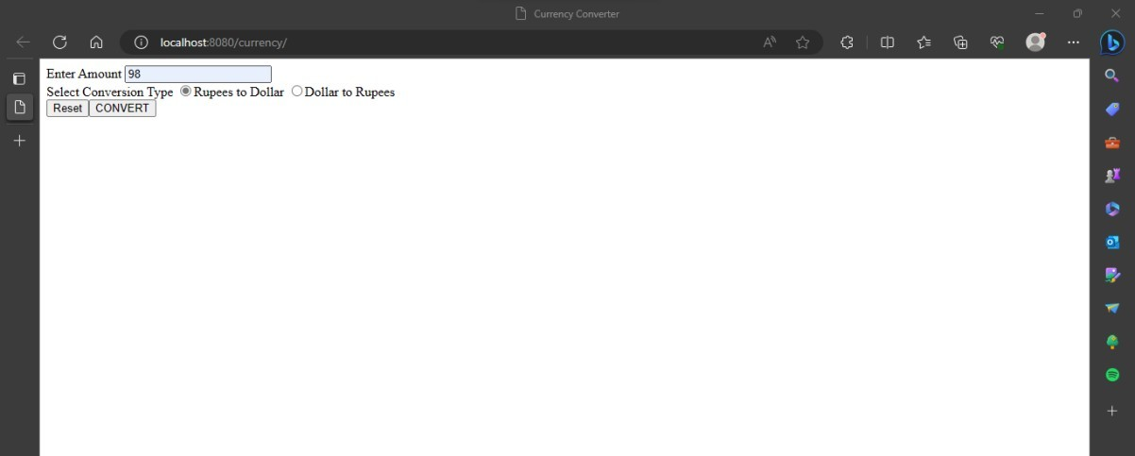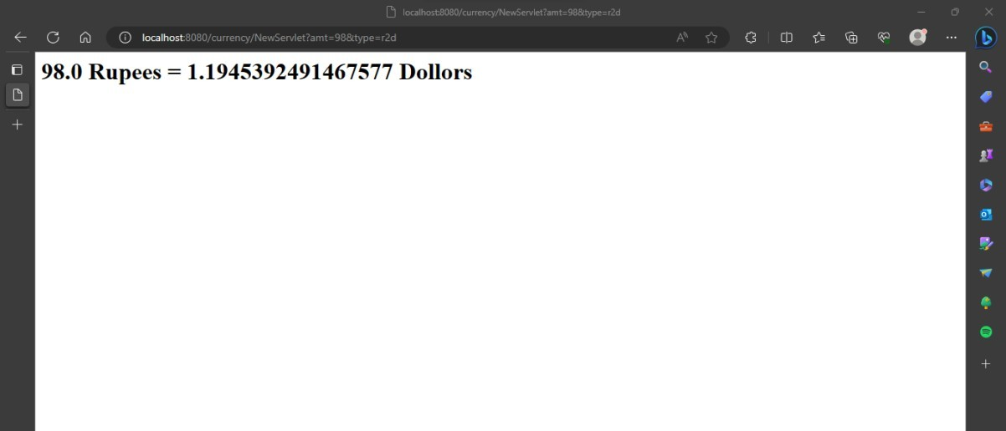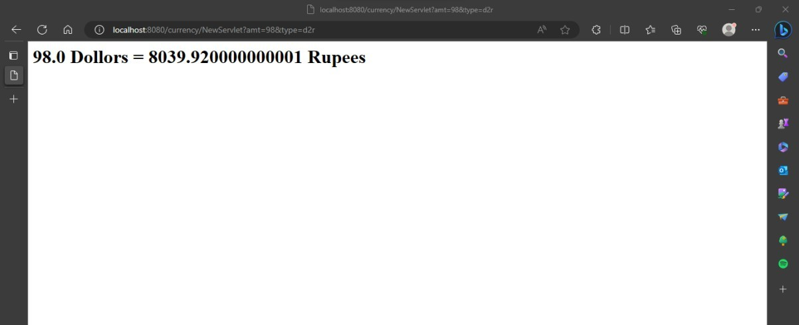

**Practical7**

# Aim::Use of Request Dispatcher to welcome user

## HTML Code: index.html

<html>

<head>

<title>prat 1c</title>

<meta charset="UTF-8">

<meta name="viewport" content="width=device-width, initial-scale=1.0">

</head>

<body bgcolor="lightblue">

<center>

<form method="post" action="NewServlet">

User name<input type="text" name="t1"><br> Password<input type="password" name="p1"><br>

<input type="submit">

</form>

</center>

</body>

</html>

## Servlet 1 Code:NewServlet

package mypack;

import java.io.IOException; import java.io.PrintWriter;

import javax.servlet.RequestDispatcher; import javax.servlet.ServletException;

import javax.servlet.annotation.WebServlet; import javax.servlet.http.HttpServlet;

import javax.servlet.http.HttpServletRequest; import javax.servlet.http.HttpServletResponse;

@WebServlet(name = "Checklogin", urlPatterns = {"/Checklogin"}) public class NewServlet extends HttpServlet {

protected void processRequest(HttpServletRequest request, HttpServletResponse response)

throws ServletException, IOException

{ response.setContentType("text/html;charset=UTF- 8");PrintWriter out = response.getWriter(); out.println("<!DOCTYPE html>"); out.println("<html>"); out.println("<head>");

out.println("<title>Servlet Checklogin</title>"); out.println("</head>");

out.println("<body>");

String p=request.getParameter("p1");if(p.equals("root"))

{

RequestDispatcherrd=request.getRequestDispatcher("Welcome"); rd.forward(request, response);

}

else

{

RequestDispatcherrd=request.getRequestDispatcher("index.html"); out.println("Invalid Login");

rd.include(request, response);

}

out.println("</body>"); out.println("</html>");

}

}

## Servlet 2 Code: welcome.java

package mypack;

import java.io.IOException; import java.io.PrintWriter;

import javax.servlet.ServletException; import javax.servlet.annotation.WebServlet; import javax.servlet.http.HttpServlet;

import javax.servlet.http.HttpServletRequest; import javax.servlet.http.HttpServletResponse;

@WebServlet(name = "Welcome", urlPatterns = {"/Welcome"}) public class welcome extends HttpServlet {

protected void processRequest(HttpServletRequest request, HttpServletResponse response)

throws ServletException, IOException

{ response.setContentType("text/html;charset=UTF- 8");PrintWriter out = response.getWriter();

out.println("<!DOCTYPE html>"); out.println("<html>");

out.println("<head>"); out.println("<title>Servlet Welcome</title>"); out.println("</head>"); out.println("<body>");

out.println("Welcome!! "+ request.getParameter("t1")); out.println("</body>");

out.println("</html>");

}

}

## Output:

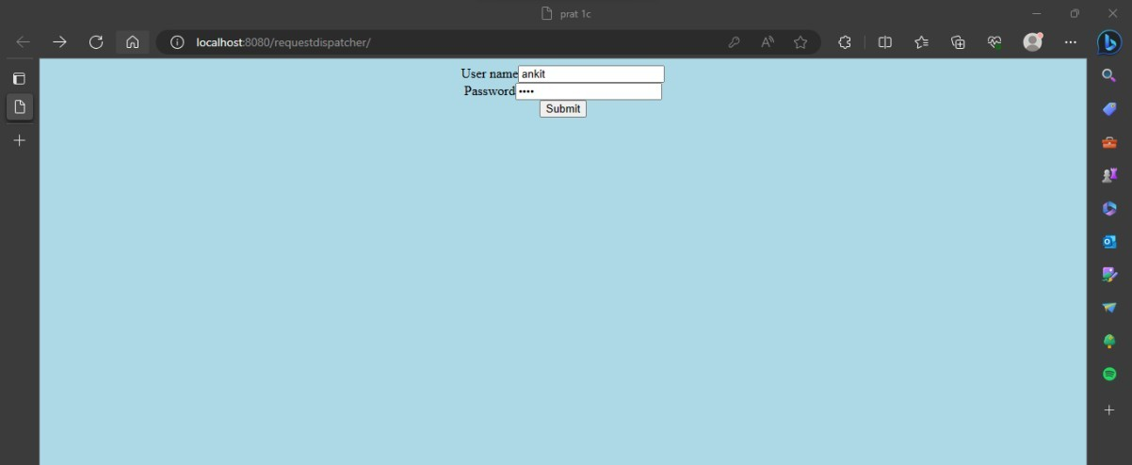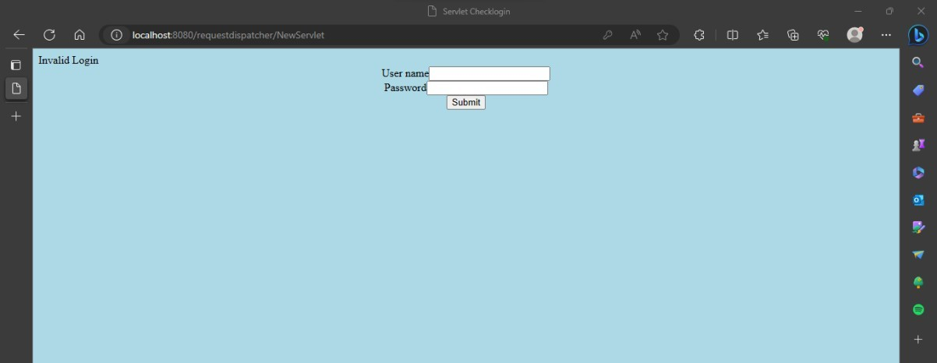

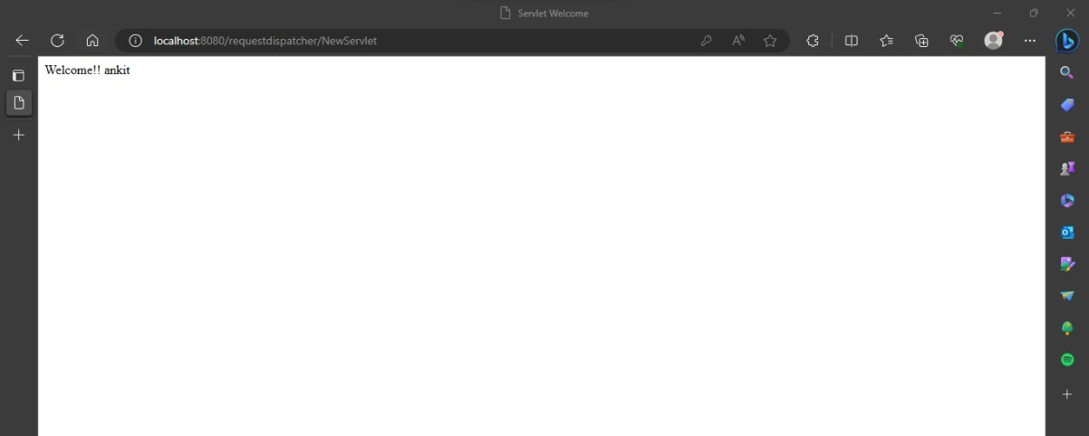

**Practical 8**

## Aim: Working with JSTL. HTML Code: index.html

<html>

<head>

<title>JSP Page</title>

</head>

<body>

<h1>hello world!</h1>

<form action="newjsp.jsp">

fname:<input type="text" name="ufname"/><br> lname:<input type="text" name="ulname"/><br>

<input type="submit" value="click"/>

</form>

</body>

</html>

## JSP Code:newjsp.java

<html>

<head>

<meta http-equiv="Content-Type" content="text/html; charset=UTF-8">

<title>JSP Page</title>

</head>

<body>

<b>Welcome ${param.ulname} ${param.ufname}</b><br>

<h1>Hello World! hihihii m jsp</h1><br>

<h1>get sum maths here</h1><br>

<p>is 5 less than 10? ${5<10}<br> 8*5=${8*5}<br></p>

</body>

</html>

## Output:

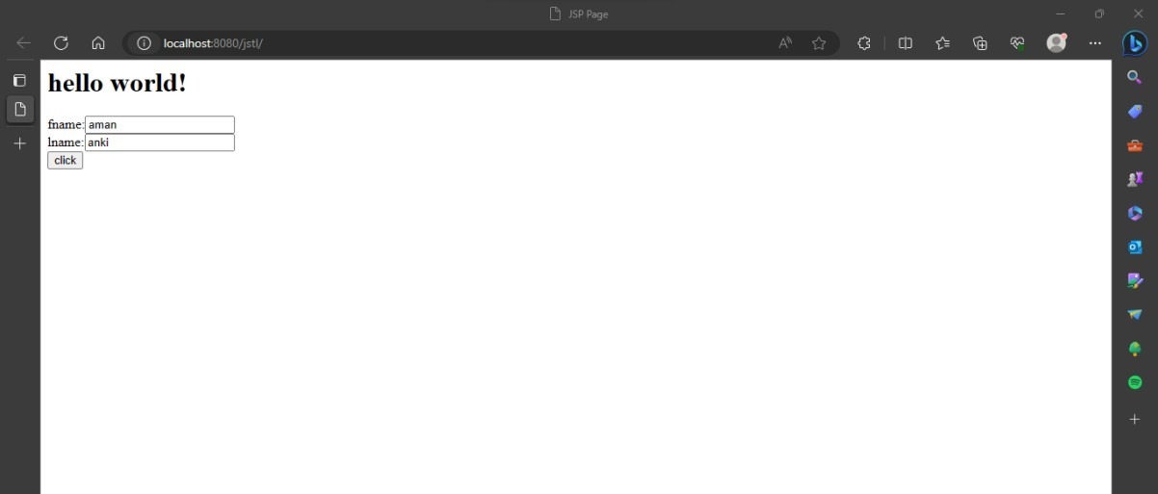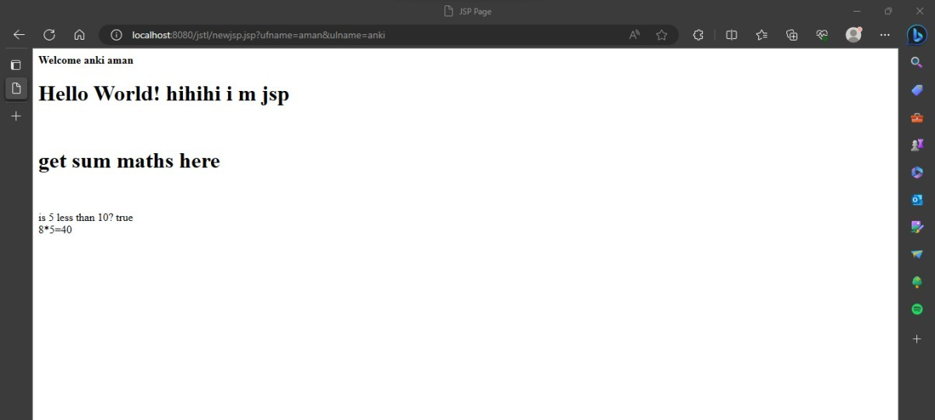

**Practical 9**

## Aim: To view data from database after submitting.. HTML Code: index.html

<html>

<body>

<form action="Newservlet" method="post">

User name :<input type="text" name="uname"><br> Password :<input type="password" name="pw"><br> Email Id :<input type="text" name="email"><br> Country :<select name="coun">

<option>select...

<option> India

<option> Bangladesh

<option> Bhutan

<option> Canada

<option>russia

</select><br>

<input type="submit" value=" Register">

</form>

</body>

</html>

## Servlet Code:NewServlet.java

package com.test; import java.io.*; import java.sql.*; import javax.servlet.*;

import javax.servlet.http.*;

public class Newservlet extends HttpServlet

{ public void doPost(HttpServletRequest request, HttpServletResponse response) throws

IOException, ServletException

{ Connection con=null; PreparedStatementps=null; response.setContentType("text/html"); PrintWriter out = response.getWriter();

String uname=request.getParameter("uname"); String pw=request.getParameter("pw");

String email=request.getParameter("email"); String country=request.getParameter("coun"); try

{ Class.forName("com.mysql.jdbc.Driver");

con=DriverManager.getConnection("jdbc:mysql://localhost:3306/test","root"," root");

out.println("connection done successfully..."); ps=con.prepareStatement("insert into user values (?,?,?,?)"); ps.setString(1,uname);

ps.setString(2,pw);

ps.setString(3,email); ps.setString(4,country); ps.execute();

out.print("Data insserted successfully!!!!");

}

catch(Exception e) { out.println(e); } out.println("<b>"+"<b>");

}

}

## Output:

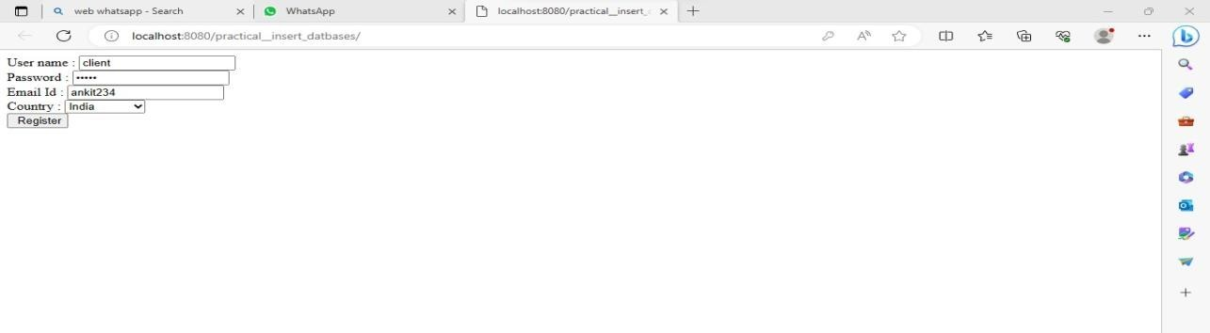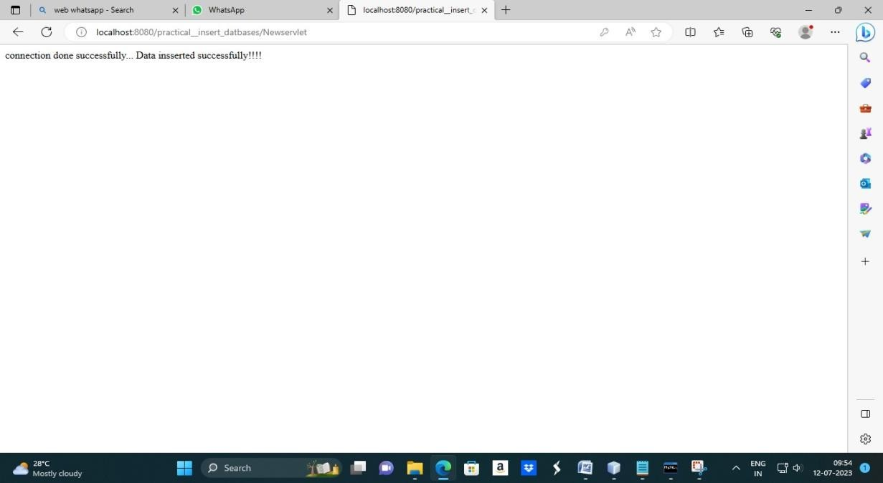

**>>create database practical;**

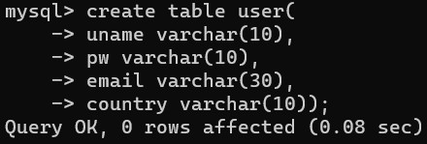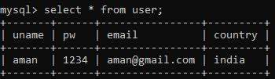

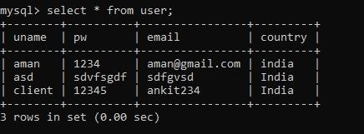

## Practical 10

**Aim: Register user in database(Room booking). HTML CODE: index.html**

<html>

<head>

<title></title>

</head>

<body>

<form action="pack" method="get"> Select A room Type

<br>

<input type="radio" id="delux" name="txtType" value="Delux">

<label for="delux">Delux</label>

<br>

<input type="radio" id="superdelux" name="txtType" value="SuperDelux">

<label for="superdelux">Super Delux</label>

<br>

<input type="radio" id="suit" name="txtType" value="Suit">

<label for="suit">Suit</label>

<br>

Enter Your Name<input type="text" name="txtCust"><br> Enter Mobile No.<input type="tel" name="txtMob"><br>

<button type="reset">Reset</button><br><button type="submit">Submit</button>

</form>

</body></html>

## Servlet 1 Code: pack.java

package mypack; import java.io.*; import javax.servlet.*;

import javax.servlet.http.*; import javax.ejb.EJB; import myBeans.RRbeans;

public class pack extends HttpServlet

{@EJB RRbeans obj;

public void doGet(HttpServletRequest request, HttpServletResponse response) throws ServletException, IOException{

PrintWriter out=response.getWriter(); String rt=request.getParameter("txtType"); String cn=request.getParameter("txtCust"); String cm=request.getParameter("txtMob"); String msg = obj.roomBook(rt, cn, cm); out.println(msg);

}}

## Servlet 2 Code: RRbeans.java

package myBeans;

import javax.ejb.Stateless; import java.sql.*; @Stateless

public class RRbeans

{public RRbeans(){}

public String roomBook(String rt, String cn, String cm){

String msg=""; try{

Class.forName("com.mysql.jdbc.Driver"); Connection con =

DriverManager.getConnection("jdbc:mysql://localhost:3306/info","root","hr");

String query="select * from roombook where RoomType=? and status='NotBooked'";

PreparedStatementpst = con.prepareStatement(query); pst.setString(1,rt);

ResultSetrs= pst.executeQuery(); if(rs.next()){

String rno=rs.getString(1);

PreparedStatement stm1 = con.prepareStatement("update roombook set cust=? where RoomId=? ");

PreparedStatement stm2 = con.prepareStatement("update roombook set mob=? where RoomId=? ");

PreparedStatement stm3 = con.prepareStatement("update roombook set status=? where RoomId=? ");

stm1.setString(1,cn); stm1.setString(2,rno); stm2.setString(1,cm); stm2.setString(2,rno); stm3.setString(1, "Booked"); stm3.setString(2,rno); stm1.executeUpdate();

stm2.executeUpdate(); stm3.executeUpdate();

msg = "Room "+rno+ " Booked <br> Charges = "+rs.getString(3);

}

else

{

msg = "Room "+rt+ " currently Not available";

}

}catch(Exception e){msg=""+e;} return msg;}}

## Output:

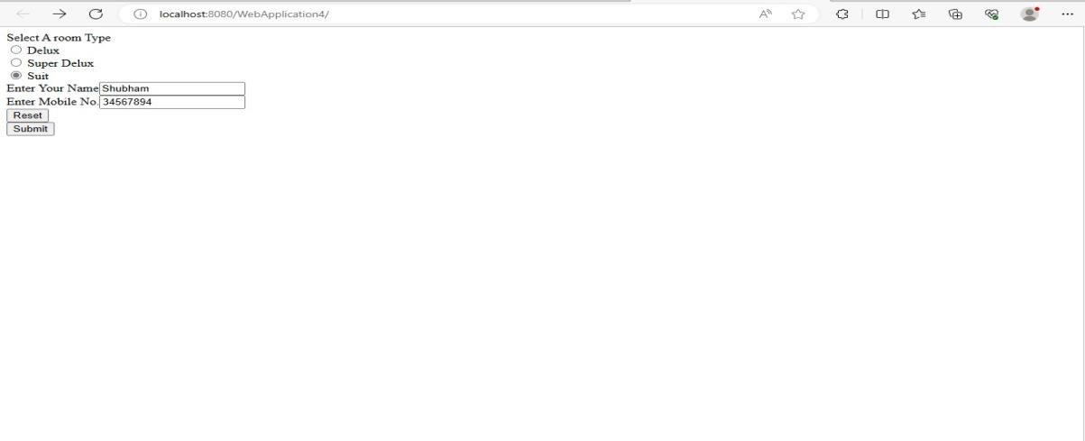

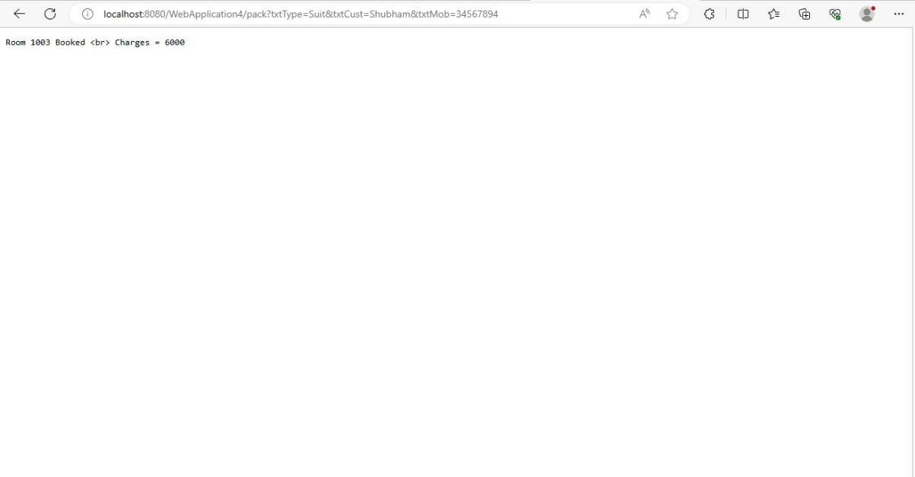

* Create database info;

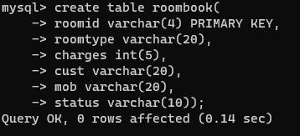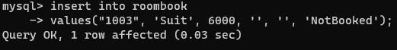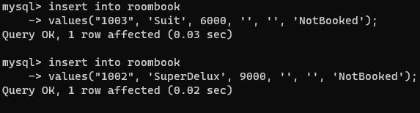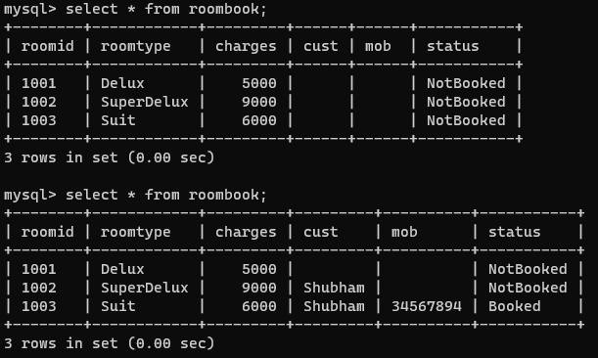

# Practical 11

**Aim: Validating user by JSP. Html code: index.html**

<html>

<head>

<title>User Information Page</title>

</head>

<body>

<form action="validate.jsp">

Enter Your Name<input type="text" name="name" ><br> Enter Your Age<input type="text" name="age" ><br> Select Hobbies

<input type="checkbox" name="hob" value="Singing">Singing

<input type="checkbox" name="hob" value="Reading">Reading Books

<input type="checkbox" name="hob" value="Football">Playing Football<br> Enter E-mail<input type="text" name="email" ><br>

Select Gender

<input type="radio" name="gender" value="male">Male

<input type="radio" name="gender" value="female">Female

<input type="radio" name="gender" value="other">Other<br>

<input type="hidden" name="error" value="">

<input type="submit" value="Submit Form">

</form>

</body>

</html>

# JSP code: Validate.jsp

<%@page contentType="text/html" pageEncoding="UTF-8" import="mypack.*" %>

<html><head><title>JSP Page</title></head>

<body>

<h1>Validation Page</h1>

<jsp:useBean id="obj" scope="request" class="mypack.CheckerBean" >

<jsp:setProperty name="obj" property="*"/>

</jsp:useBean>

<%if (obj.validate())

{ %>

<jsp:forward page="successful.jsp"/>

<% }

else {%>

<jsp:include page="index.html"/>

<%}%>

<%=obj.getError() %>

</body>

</html>

# Servlet code: CheckerBean.java

package mypack;

public class CheckerBean {

private String name, age, hob, email, gender, error; public CheckerBean(){error="";}

public void setName(String n){name=n;} public void setAge(String a){age=a;} public void setHob(String h){hob=h;} public void setEmail(String e){

email=e;

}

public void setGender(String g){gender=g;} public void setError(String e){error=e;} public String getName(){return name;} public String getAge(){return age;}

public String getHob(){return hob;} public String getEmail(){return email;} public String getGender(){return gender;} public String getError(){return error;} public booleanvalidate(){

boolean res=true;

if(name.trim().equals("")) {error+="<br>Enter First Name";res=false;} if(age.length() > 2 )

{error+="<br>Age Invalid";res=false;} return res; } }

**JSP2 Code: successful.jsp**

<%@page contentType="text/html" pageEncoding="UTF-8"%>

<!DOCTYPE html>

<html>

<head>

<meta http-equiv="Content-Type" content="text/html; charset=UTF-8">

<title> JSP Page</title>

</head>

<body>

<h1>Data Validated Successfully!!</h1>

</body>

</html>

**Output:**

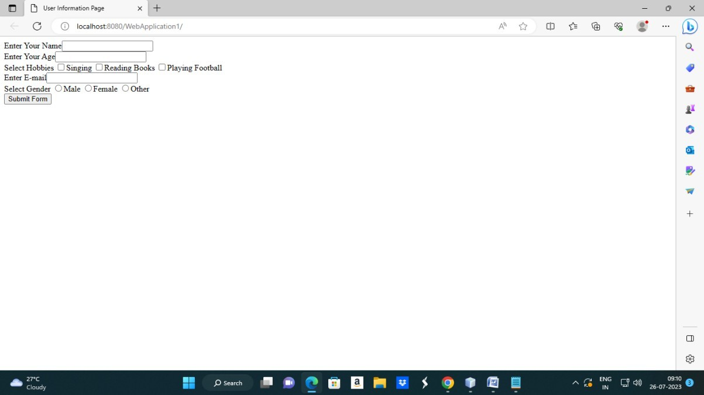

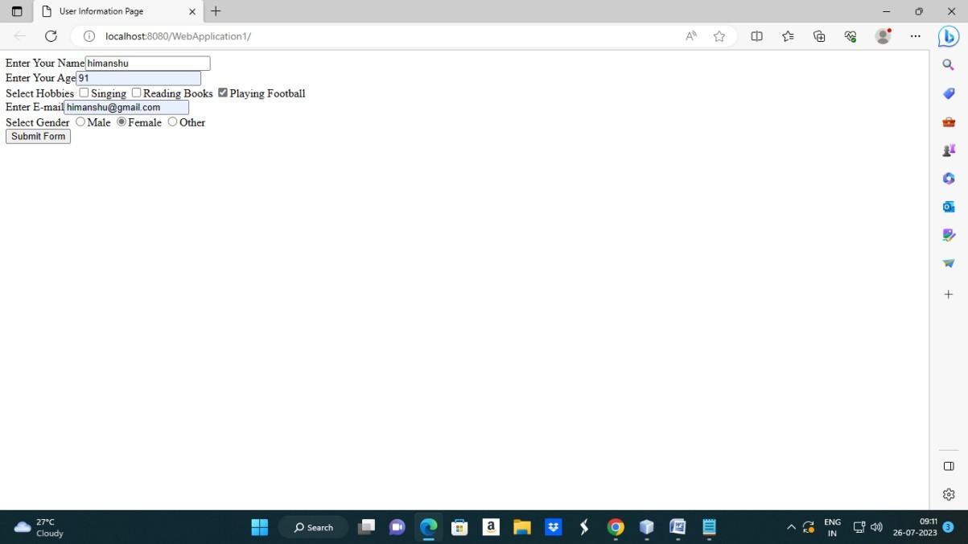

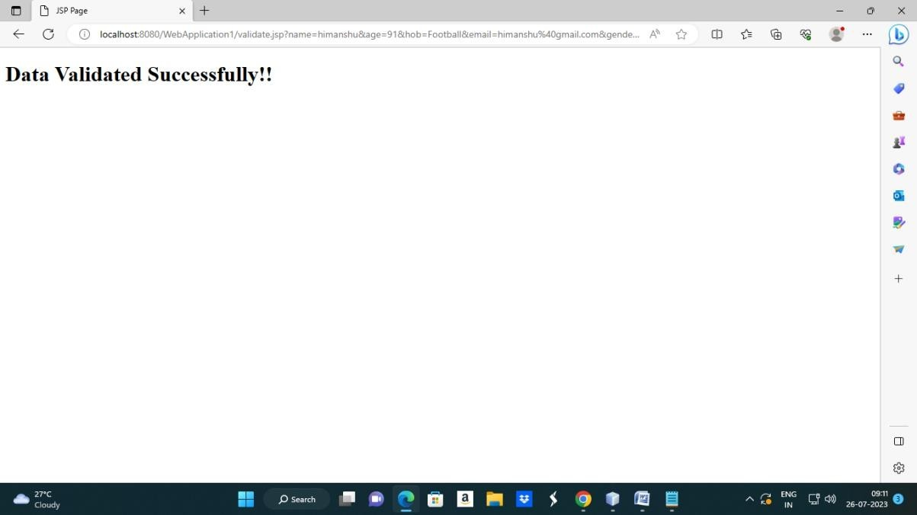

# Practical 12

**Aim: Create a registration and login JSP application to register and authenticate the user based on username and password using JDBC.**

# Html code: index.html

<html><head><title>New User Registration Page</title></head>

<body>

<form action="register.jsp" >

<h1> New User Registration Page</h1>

Enter User Name <input type="text" name="txtName" ><br> Enter Password <input type="password" name="txtPass1" ><br>

Re-Enter Password<input type="password" name="txtPass2" ><br> Enter Email<input type="text" name="txtEmail" ><br>

Enter Country Name <input type="text" name="txtCon" ><br>

<input type="reset" ><input type="submit" value="REGISTER" >

</form>

</body>

</html>

**JSP code: register.jsp**

<%@page contentType="text/html" import="java.sql.*"%>

<html><body>

<h1>Registration JSP Page</h1>

<%

String uname=request.getParameter("txtName"); String pass1 = request.getParameter("txtPass1"); String pass2 = request.getParameter("txtPass2"); String email = request.getParameter("txtEmail"); String ctry = request.getParameter("txtCon"); if(pass1.equals(pass2)){

try{ Class.forName("com.mysql.jdbc.Driver");

Connection con = DriverManager.getConnection("jdbc:mysql://localhost:3306/test","r oot","hr");

PreparedStatementstmt = con.prepareStatement("insert into register values (?,?,?,?,?)");

stmt.setString(1, uname); stmt.setString(2, pass1);

stmt.setString(3, pass2);stmt.setString(4, email); stmt.setString(5, ctry);

int row = stmt.executeUpdate();

if(row==1) { out.println("Registration Successful"); } else {

out.println("Registration FFFFFAAAIIILLLL !!!!");

%><jsp:include page="index.html" ></jsp:include>

<%

}

}catch(Exception e){out.println(e);}

}

else

{

out.println("<h1>Password Mismatch</h1>");

%>

<jsp:include page="index.html" ></jsp:include>

<% }

%>

</body>

</html>

# Output:

* **create database test;**

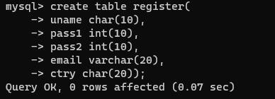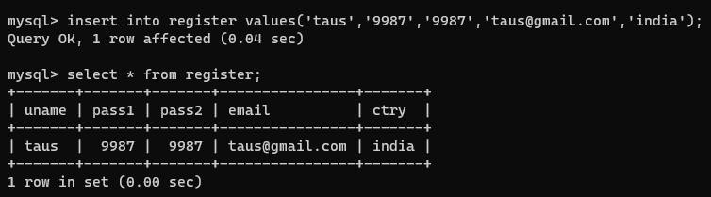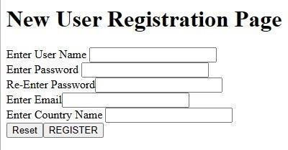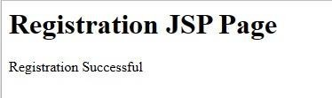

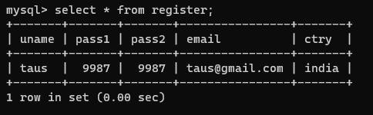

# Practical 13

**Aim: Create a servlet application to Uploading File.**

# Code:

**HTML CODE: index.html**

<html>

<body>

<form action="fileservletapp" method="post" enctype="multipart/form-data">

Select File to Upload:<input type="file" name="file" id="file">

<br>

Destination <input type="text" value="/tmp" name="destination">

<input type="submit" value="Upload file" name="upload" id="upload">

</form>

</body>

</html>

# Servlet code: NewServlet.java

package test; import java.io.*;

import javax.servlet.*;

import javax.servlet.annotation.MultipartConfig; import javax.servlet.http.*;

@MultipartConfig

public class NewServlet extends HttpServlet

{@Override public void

doPost(HttpServletRequestreq,HttpServletResponse res) throws ServletException,

IOException

{

res.setContentType("text/html"); PrintWriter out = res.getWriter();

String path=req.getParameter("destination"); Part filePart=req.getPart("file");

String filename=filePart.getSubmittedFileName(); out.print("<br><br><hr> file name: "+filename); OutputStreamos=null;

InputStream is=null;

try {

os=new FileOutputStream(new File(path+File.separator+filename));

is=filePart.getInputStream(); int read=0;

while ((read = is.read()) != -1)

{os.write(read);

}

out.println("<br>file uploaded sucessfully...!!!");

}

catch(FileNotFoundException e){out.print(e);}

} }

# Output:

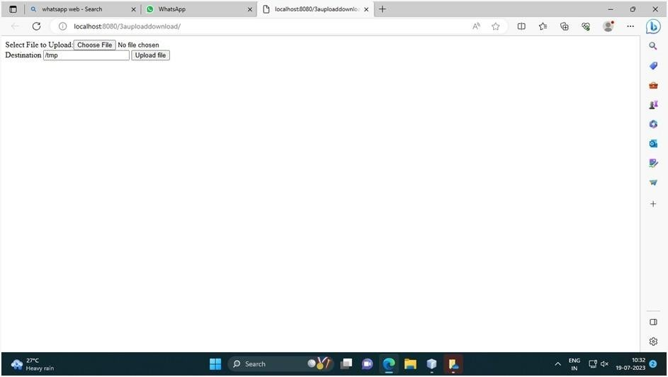

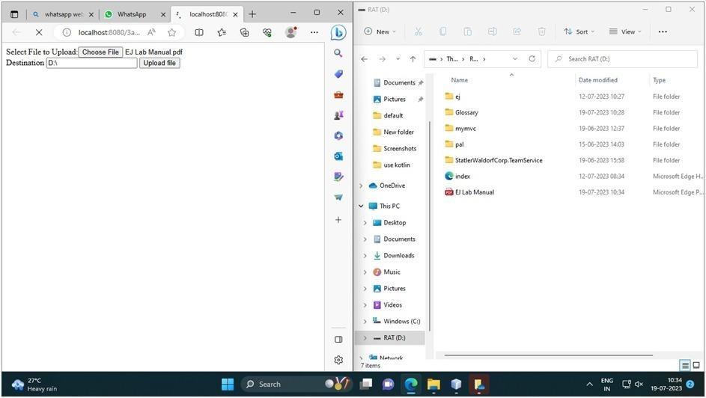

**Practical 14 Aim: To download a file:**

# HTML CODE: index.html

<html>

<head>

<title>File Download Page</title>

</head>

<body>

<h1>File Download Application</h1>

Click <a href="DownloadServlet?filename=ejm.pdf.pdf">Sample Chapter</a>

<br/><br/>

Click <a href="DownloadServlet?filename=index.html">Table Of Contents</a>

</body>

</html>

**Servlet CODE:**DownloadServlet.java package filedownloadapp;

import java.io.IOException; import java.io.InputStream; import java.io.PrintWriter;

import javax.servlet.ServletContext; import javax.servlet.ServletException; import javax.servlet.http.HttpServlet;

import javax.servlet.http.HttpServletRequest; import javax.servlet.http.HttpServletResponse; public class DownloadServlet extends HttpServlet

{@Override

public void doGet(HttpServletRequest request, HttpServletResponse response)

throws ServletException, IOException

{ response.setContentType("APPLICATION/OCTET- STREAM");String filename = request.getParameter("filename"); ServletContext context

= getServletContext(); PrintWriter out;

//ServletOutputStream out = response.getOutputStream();

// any of the two works

try (InputStream is = context.getResourceAsStream("/" + filename)) {

//ServletOutputStream out = response.getOutputStream(); // any of the two works

out = response.getWriter();

response.setHeader("Content-Disposition","attachment; filename=\"" + filename + "\""); //

//if comment this statement then it wl ask you about the editor with which you want to open the file

int i;

while ((i=is.read()) != -1)

{out.write(i);

} }

out.close();

}

}

Output:

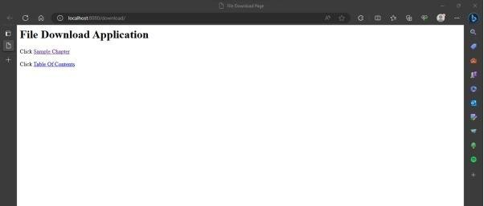

# Practical 15 Aim: To Create Quiz using Servlet.

**Html code:** index.html Code:

<html>

<head>

<title>Quiz Application</title>

</head>

<body>

<h1>Welcome to Quiz Servlet </h1>

<h1><a href="NewServlet" >CLICK TO START QUIZ</a></h1>

</body>

</html>

**Servlet1 Code:**NewServlet.java **Code:**

package test; import java.io.*; import java.sql.*;

import javax.servlet.*; import javax.servlet.http.*;

public class NewServlet extends HttpServlet {

public void doGet(HttpServletRequest request, HttpServletResponse response)

throws ServletException, IOException

{ response.setContentType("text/html;charset=UTF- 8");PrintWriter out = response.getWriter(); out.println("<form action=showresult>");

try

{ Class.forName("com.mysql.jdbc.Driver"); Connection con =

DriverManager.getConnection("jdbc:mysql://localhost:3306/qadb"," root","hr");

Statement stmt = con.createStatement();

ResultSet res = stmt.executeQuery("select * from quiz"); out.println("<table border=1 >");

int qno=0; while(res.next()){ qno++;

out.println("<tr><td>"+res.getString(1)+"</td>"); out.println("<td>"+res.getString(2)+"</td></tr>");

out.println("<tr><td><input type=radio name="+qno+"value="+res.getString(3)+"></td><td>"+res.getString(3)+"</ td></tr>");

out.println("<tr><td><input type=radio name="+qno+"value="+res.getString(4)+"></td><td>"+res.getString(4)+"</ td></tr>");

out.println("<tr><td><input type=radio name="+qno+"value="+res.getString(5)+"></td><td>"+res.getString(5)+"</ td></tr>");

out.println("<tr><td><input type=radio name="+qno+"value="+res.getString(6)+"></td><td>"+res.getString( 6)+"</ td></tr>");

}

}

catch(Exception e)

{out.println(e);} out.println("</table>"); out.println("<input type=reset >");

out.println("<input type=submit value=SUBMIT >"); out.println("</form>");

}

}

**Servlet2 code:**showresult.java **Code:**

package test; import java.io.*; import java.sql.*;

import javax.servlet.*; import javax.servlet.http.*;

public class showresult extends HttpServlet {

public void doGet(HttpServletRequest request, HttpServletResponse response)

throws ServletException, IOException {

response.setContentType("text/html;charset=UTF-8"); PrintWriter out = response.getWriter();

try

{ Class.forName("com.mysql.jdbc.Driver"); Connection con =

DriverManager.getConnection("jdbc:mysql://localhost:3306/qadb"," root","hr");

Statement stmt = con.createStatement();

ResultSet res = stmt.executeQuery("select ans from quiz"); int count =0, qno=0;

while(res.next()){ if(res.getString(1).equals(request.getParameter(""+(++qn o))))

{ count++; out.println("<h1>Correct </h1>");

}

else {

out.println("<h1>Incorrect </h1>");

}

}

out.println("<h1>Your Score is "+count+" </h1>");

}

catch(Exception e)

{out.println(e);

}}}

**SQL commands**

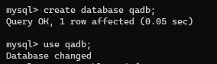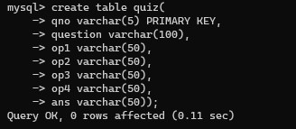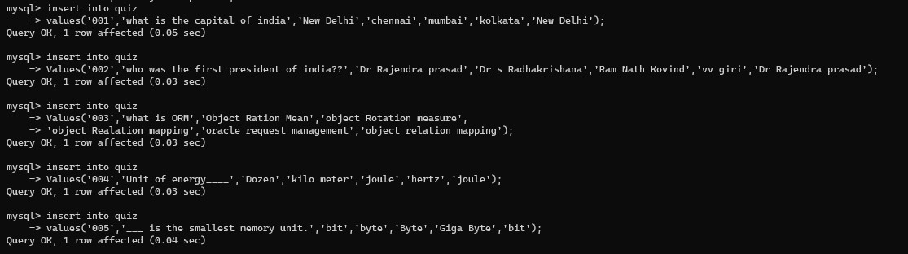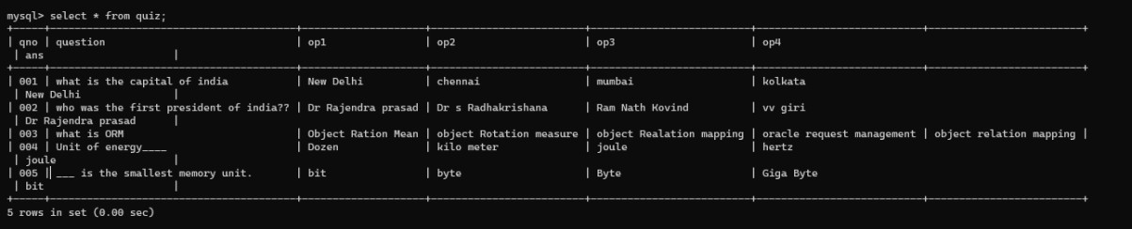

**Output:**

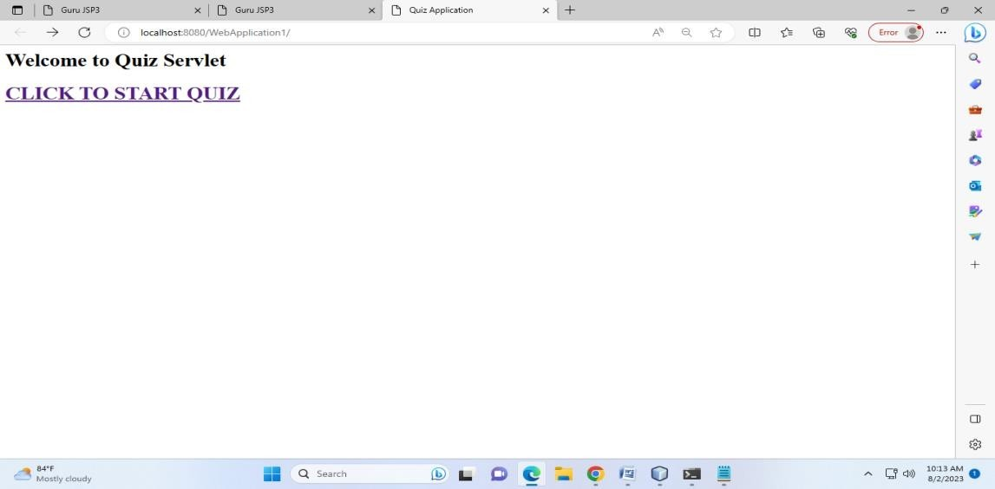

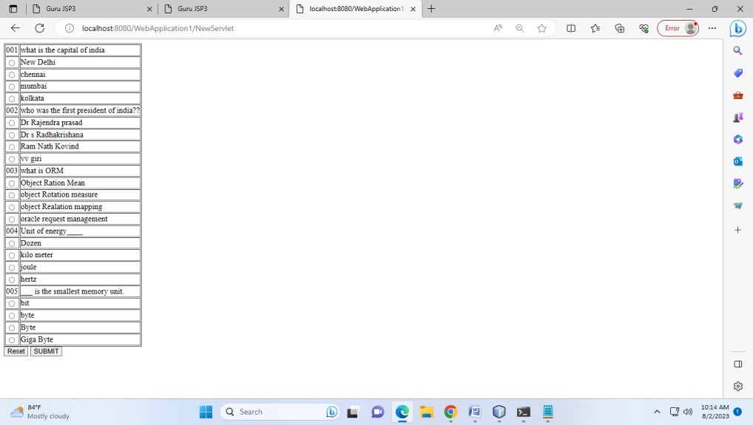

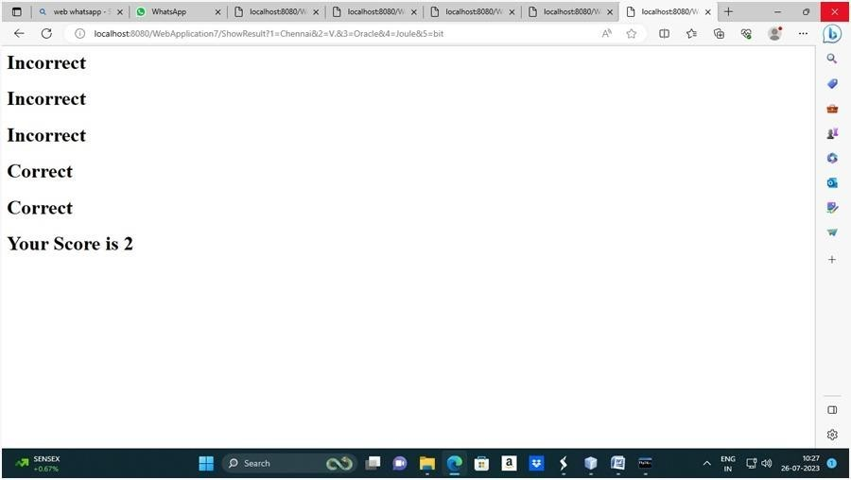

# Practical 16 Aim: Expression language by using JSP. JSP code: newjsp.jsp

Code:

<%@ page language="java" contentType="text/html; charset=ISO-8859-1"

pageEncoding="ISO-8859-1"%>

<!DOCTYPE html PUBLIC "-//W3C//DTD HTML 4.01

Transitional//EN" "<http://www.w3.org/TR/html4/loose.dtd>">

<html>

<head>

<meta http-equiv="Content-Type" content="text/html; charset=ISO-8859-1">

<title>Guru JSP3</title>

</head>

<body>

<%! int week=8; %>

<%

switch(week){ case 1: out.println("Sunday");

break; case 2:

out.println("Monday");

break; case 3:

out.println("Tuesday"); break;

case 4: out.println("wednesday");

break; case 5:

out.println("Thursday"); break;

case 6: out.println("Friday");

break; case 7:

out.println("Saturday"); break;

default: out.println("Invalid Input"); break;}

%>

</body>

</html>

**Output:**

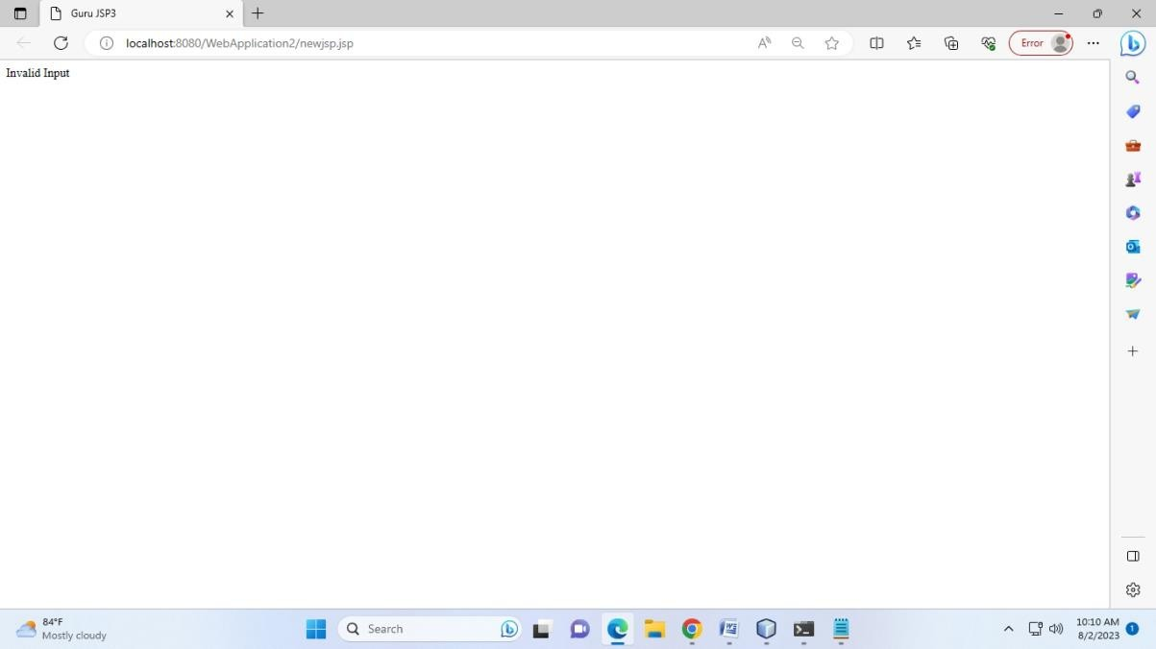

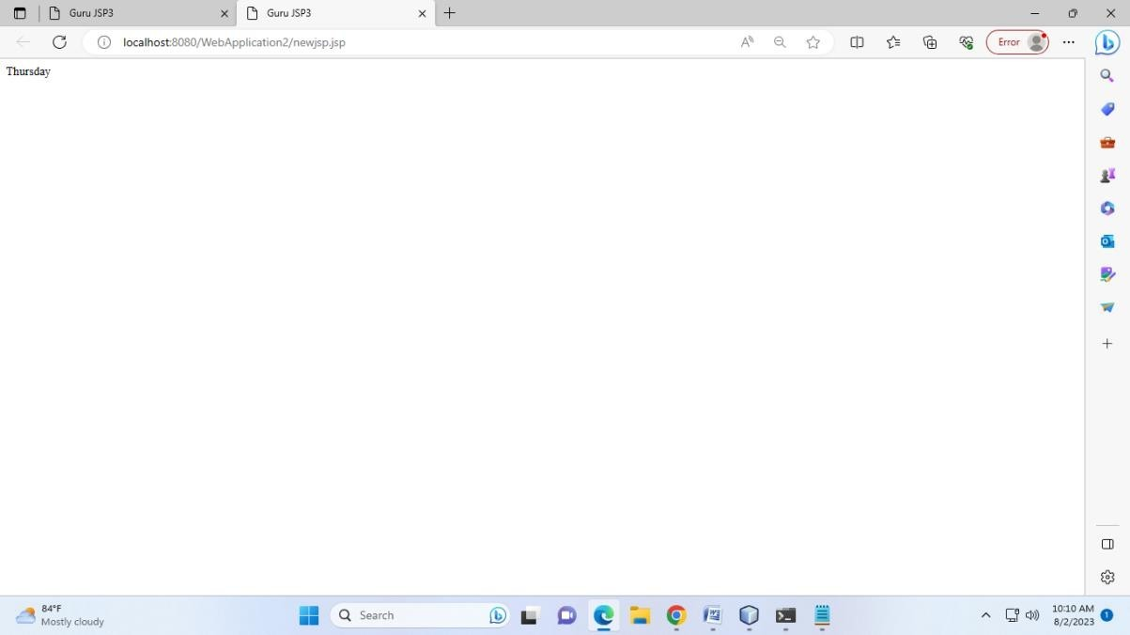

# Practical 17

**Aim: Use JDBC for data insertion for valid user HTML Code:** index.html

<html>

<body bgcolor="lightgreen" >

<center>

<form action="NewServlet" method="post">

User name : <input type="text" name="uname"> <br><br> Password : <input type="password" name="pw"><br><br> Email Id : <input type="text" name="email"> <br><br>

<input type="submit" value=" Register">

</form>

</center>

</body>

</html>

**Servlet Code:** NewServlet.java

package mypack; import java.io.*; import java.sql.*; import javax.servlet.*;

import javax.servlet.http.*;

public class NewServlet extends HttpServlet

{ public void doPost(HttpServletRequest request, HttpServletResponse response) throws

IOException, ServletException

{ Connection con=null; PreparedStatement ps=null; response.setContentType("text/html"); PrintWriter out = response.getWriter();

String uname=request.getParameter("uname"); String pw=request.getParameter("pw");

String email=request.getParameter("email");

If (uname.equals("admin") && pw.equals("12345")){{ out.println("<body bgcolor= lightblue >");

out.println("<h1><center> Welcome !!! "+uname+"</center></h1>");

}

try

{ Class.forName("com.mysql.jdbc.Driver"); con=DriverManager.getConnection("jdbc:mysql://localhost:3306/office", "root","root");

ps=con.prepareStatement("insert into emp values (?,?,?)"); ps.setString(1,uname);

ps.setString(2,pw); ps.setString(3,email); ps.execute();

out.print("<h1><center>Data inserted successfully!!!!</center></h1>");

}

catch(Exception e) { out.println(e); } out.println("<b>"+"<b>");

}

else{

out.println("<body bgcolor= red >"); out.println("<h1><center> Login Fail !!! </center></h1>");

}}

}

**SQL Commands:**

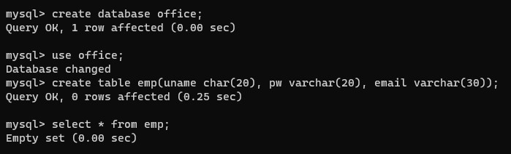

**Output:**

